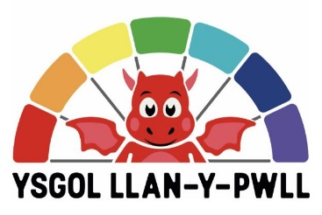
Letter from the Headteacher
Welcome to Ysgol Llan-y-pwll's website. Here you will have the opportunity to find out all types of information about the new school which is opening in September 2022. Ysgol Llan-y-pwll believes in fostering an active, happy and safe environment based on strong relationships between children and staff. We will always strive to create a caring and stable environment. Our primary objective is to develop a safe learning environment where all individuals are respected and challenged. We will praise the individual's achievements and encourage them to do their best socially, morally and academically. To maintain this there must be an honest partnership between teachers, parents/ guardians and children. The school belongs to us all.
Each child's needs will be met through work that is designed to suit the individual's ability. Ysgol Llan-y-pwll will be a school where all pupils are equal and are challenged to reach their full potential in a friendly, caring, welcoming and creative atmosphere. With the establishment of the Curriculum for Wales, every pupil will have the opportunity to develop and reach their full potential through a variety of lessons and tasks that interest them. Central to this will be using and developing the Welsh language and learning about our heritage. The use of the outdoor area will also be very important in the school. It is essential that all children acquire education and have full access to the experiences, knowledge and the skills they need in the world of work for lifelong learning and active citizenship.
Finally, we hope we make your child's years in our care happy, memorable and successful. The school will prepare pupils to be capable, confident, happy and independent individuals throughout their lives.

Yours faithfully,
Mrs Rhiannon James
Headteacher

